Instructional Method (MODALITY)
Workshop #1 (October 20th, 2023)

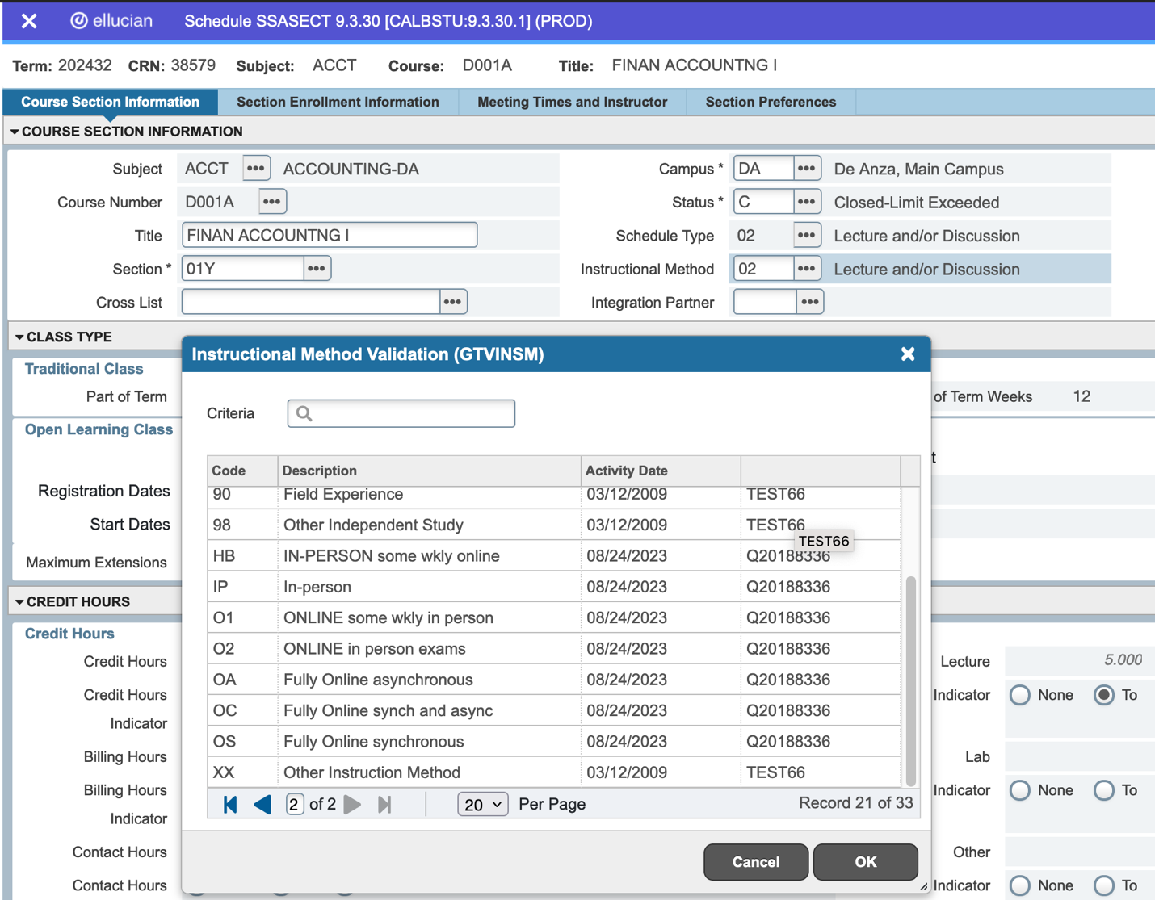
Instructional Method (modality) Choices
Schedule Type
Instructional Method (modality)

Instructional Method (1st Block of SSASECT)

- The Instructional Method field in the 1st block of SSASECT is not reported to the state. The field is available to students as a query option only. In SSB 9, the Instructional Method field is searchable and is used to represent class modality.

- List of Instructional Method (modality) codes we will be using in the 1st block of SSASECT:

Instructional Method Code  (Modality) | DESCRIPTION | COMMENT
IP | In-person | Use this code for in-person class, on-campus or off-campus. I.E: KNES 22AX.01 MW 9:30-10:45am PE14
HB | IN-PERSON-some wkly online | Use this code if the class is mostly in-person, 50% or more IN-PERSON. This is a "true Hybrid" because it meets the state's definition of a Hybrid. I.E: MATH 1A (5 units), MTWR 8:30-9:20am G5 and 1 Hour Online.
O1 | ONLINE-some wkly in-person | Use this code if the class is mostly online, 51% or more ONLINE. This type of class is defined as online by the state. I.E: EWRT 1A (5 units), Monday 1:30-3:20 MLC260 and 3 Hours Online.
O2 | ONLINE-in-person exams | Use this code if the class is 100% online, but exams and tests are on-campus, in-person. I.E. ACCT 1A.50Z (5 units) 5 hours Online, exams/tests are on-campus. 10/23/23 - Per Christina Espinosa-Pieb, classes with this modality must be coded with a “Y” in the section number, instead of a “Z”.
OS | Fully Online–synchronous | Use this code if the class is 100% online, synchronously. Exams and tests are also online.
OA | Fully Online–asynchronous | Use this code if the class is 100% online, asynchronously. Exams and tests are also online.
OC | Fully Online–syn & async | Use this code if the class is 100% online, with some synchronous and asynchronous methods. Exams and tests are also online.
XX | Other Instruction Method | For PDL, Release Time, and Sick Leave dummy assignments only.

- Instructional Method code is rolled from year to year. If you are changing class modality, please make sure you input the appropriate Instructional Method (modality) code in the 1st block of SSASECT. This field is modifiable until registration starts. Once the class has registration, Banner prohibits change to this field.

“DW” (De Anza Web) Building Code – impacts meeting block of SSASECT
- In the past all on-campus rooms in Banner are tied to “DA” building code, including “ONLINE” room. We recently created a new “DW” (De Anza Web) building code, this code must be used for all meeting line that has “ONLINE” listed as the room location. If you attempt to use anything else for ONLINE room, you will see a Banner error message.
- ETS and I have already updated “DW” building code to all classes that have “ONLINE” room listed. We made changes for Summer 2023 (202412), Fall 2023 (202422), and Winter 2024 (202432) terms.

Schedule Type (1st Block of SSASECT)
- The Schedule Type field in the 1st block of SSASECT is not reported to the state; it is informational and is only available as a query option for students. In the past few years, we have been inputting various codes in this field and tying it to different class modalities. With SSB 9, the Schedule Type in the 1st block of SSASECT will be reduced to just two codes:
“02” - For lecture classes, such as EWRT, ACCT, HUMA, etc;
“02” - For classes that have BOTH lecture and lab hours, such as CHEM, BIOL, CIS, AUTO, etc.
“04” – For purely lab classes, such as KNES or PE.

- Schedule Type is rolled from year to year. If the class rolled with an incorrect Schedule Type code, changing it is arduous because it requires removing the instructor and meeting information. I will work with ETS to correct all of the Schedule Type code for Summer 2023, Fall 2023, Winter 2024, and Spring 2024. After these fixes, all of the schedule type codes will be corrected and when we roll from year to year, the classes would have the correct schedule type codes. You would not need to make any Schedule Type changes for rolled classes. But if you are adding a NEW class, please remember to appropriately select “02” or “04” codes, and nothing else.

