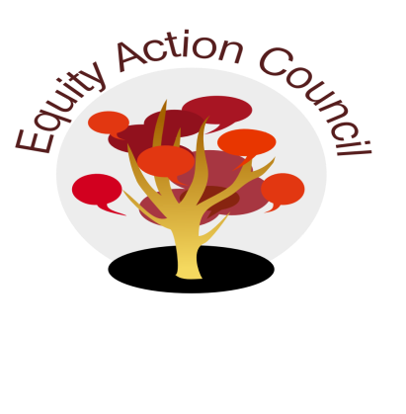
Time | Topic | Process | Facilitator(s)
1:30pm | Introduction | - Quiet time 3 minutes  - Conocimiento | Edmundo Norte + Alicia Cortez
1:50pm | Update | - College Planning Committee | Mallory Newell
2:20pm | Committees | - EAC Reaffirmation Statement Subcommittee Report | Subcommittee
 |  | - Equity Champion Awards Nominations, Criteria, Process & Selection  - Call for sub-committee | Alicia Cortez
2:50pm | Closure | - Announcements  - Appreciations | All

EAC Community Agreements
Show up, and choose to be present
Pay attention to what has heart and meaning
Tell the truth without blame or judgment
Be open to outcome, not attached to outcome
From The Four-Fold Way® by Angeles Arrien, Ph.D.

