De Anza College

Business, Computer Science and Applied Technologies/Accounting Department
00018, Financial Accounting 1A, 06Z, Fall 2021

Course and Contact Information
Instructor: | Catherina Wong CPA MBA Hello! Welcome to financial Accounting! I look forward to meeting and working with all of you this quarter. I am here to help. The best way to reach me is through Canvas, our learning management system.  Just click on “inbox” in canvas to send me a message.
Email: | wongcatherina@fhda.edu
Office Hours: | Zoom office hours. Time, links, appointment ID and password below:  Zoom Meeting ID: 786 326 5435 Password: 458521  Monday/Wednesday 11:30 to 12:30; Tuesday/Thursday 2:30 to 3:30 pm or by appointment via Zoom
Class Days/Time: | Tuesday and Thursday 11:30 am to 1:20 pm
Classroom: | Zoom links published on Canvas
Advisory: | EWRT 211 and READ 211, or ESL 272 and 273; MATH 212 or equivalent.

Course Description

This course is designed for students to be able to demonstrate a knowledge of double entry accounting for business transactions and adjustments and prepare, explain and analyze financial statements using GAAP. In addition, students will be able to analyze fundamental business concepts, how businesses operate, how accounting serves them and identify ethical issues in an accounting context.

Course Format
This is a 5-unit hybrid course with 4 hours of lecture and 1 hour of study-on-your-own weekly. You should also plan to complete readings before you attend Zoom classes. This does not include extra time that is needed for reviewing and clarifying concepts, practice problems, and homework. This course meets 2 times a week via Zoom, where major concepts will be covered, practice problems will be demonstrated and student to instructor and student to student discussions will take place. These meetings will be recorded and links uploaded on Canvas course webpage within 24 hours. If you plan to attend the synchronous sessions, log onto Zoom on time. Listen to your instructor & peers. Be kind to others and ready to participate. Always do your best.

Technological requirements for this course:
- Desktop computer, laptop or tablet
A modern computer will be needed to take exams, attend lectures, complete homework, quizzes and projects.
- Webcam & microphone
Webcam &microphone are needed for Zoom meetings.
- Software
- You will need the google chrome web browser (free of charge)
- Please sign up for a student FHDA email account to obtain free access to Microsoft's Office 365, including Word, Excel, PowerPoint and other online software. FHDA student email account sign-up information is available at https://www.deanza.edu/students/new-tech.html
- Reliable internet
You will need reliable internet to help you access class materials and a quiet, private location for taking exams.
- Canvas mobile app (nice to have)
There is a mobile app that you can download to view course materials

Canvas Learning Management System

This course will utilize a course management system known as Canvas. Since this is a synchronous online class, a lot of our instruction will occur through this system. It is important you log on regularly (I recommend 3 times per week) to check class announcements, assignments, grades, and feedback. In addition, you can set-up your Canvas account to have announcements, assignment deadline changes and grade postings pushes notifications to your email. Your learning modules are divided by weeks. Each week consists of course content pages (task list and time estimates, recorded lectures and clipboard notes that I write during class uploaded, notes written from textbook readings, study guides from the publisher), required work pages (links to Cengage homework, post-lecture quizzes, and learning checks in the form of T/F and Multiple-choice quizzes in Canvas), and optional work pages (extra practice in Cengage and extra credit opportunities links). Some topics will take more than 1 week to cover. I post weekly Sunday announcements to communicate what we will be covering in the next week and to post PowerPoint files and PDFs by the previous Friday that I will be using in class. I recommend having your first weekly check-in on either Sunday night or Monday morning so you know the expectations and pacing for the week.
If you have already used Canvas for another course, congratulations, you already know how to log in! If you have never used Canvas (or need a refresher) view the instructions below.

From the deanza.edu website, select the canvas sign on button. Next, use your campus wide ID and password to login to canvas. Once you are logged in, you will see all the classes you are enrolled in at De Anza. Enter and enjoy!

Technical Difficulties?
If you have trouble logging on please go to https://www.deanza.edu/online-ed/help.html for more information or do one of the following listed below:

- Call 408.864.8969 Monday - Thursday 8:30am-5:00pm, Friday 8:30-4:00pm
- Email your issues to onlineeducation@deanza.edu
- Or you can open a ticket/report a problem by clicking on Help in Canvas.

It may take up to 12 hours after registration for a course to be accessible in Canvas

Course Goals/Learning Outcomes
Upon successful completion of this course, students will be able to:
- Demonstrate a knowledge of double entry accounting for business transactions and adjustments and prepare, explain and analyze financial statements using GAAP.
- Analyze fundamental business concepts, how businesses operate, how accounting serves them and identify ethical issues in an accounting context.
Course Objectives

- Recognize accounts’ role in society and how accounting meets the information needs of creditors and investors
- Analyze fundamental business concepts, how businesses operate and how accounting serves them.
- Analyze fundamental accounting concepts underlying financial statements.
- Evaluate the uses and limitations of financial statements.
- Evaluate the usefulness of information produced by an accounting system and how it is directly related to that system's design.
- Analyze ethical issues within an accounting/business framework.
- Define and explain the conceptual framework of accounting.

Required Texts/Readings

Textbook
Here is the general Cengage website for De Anza students that has really useful information on the different options for accessing accounting materials. It also has troubleshooting links and directions on how to turn off pop-ups in order to run homework smoothly on your computer. Please take a little time to browse. https://www.cengage.com/coursepages/DeAnza_Integrated

Option A: Buy one-third of the book from De Anza online Bookstore in loose-leaf format. This option includes a quarter-long access code for the required online internet access to CNOWv2. http://books.deanza.edu/SelectTermDept.aspx

Option B: Buy only the access code directly from CNOWv2. This allows you to access the text in electronic format (e-book only) and also to do the online assignments. Please follow instructions listed below.
Step 1: Sign into Canvas and click on F21 ACCT D001A Financial Accounting. The icon for this course has leaves with gold color background.
Step 2: Click on the Cengage link: Modules/Cengage Access/Link to Cengage Homework
Step 3: Create or sign into your Cengage account to access or purchase the materials for this course.
Need help? Visit startstrong.cengage.com for step-by-step registration instructions and videos.

Option C: Buy the entire textbook from another source. In this case, you will still need to buy the access code for online access. This is probably the most expensive option.
International Students: ANY STUDENT TAKING THIS COURSE FROM OUTSIDE OF THE UNITED STATES: You can visit www.cengage.com/purchase-abroad to purchase your Cengage course materials.

International Customer Support is available Monday – Friday at the phone numbers. You can also send an email to intlcs@cengage.com and that will auto-generate a case to that support team.
1 800 599 3663
1 859 657 4786
Important! Please note that we are using the 27th edition of the text, accounting, Warren etc., Cengage Publishing. If you attempt to use a later edition, homework submitted will be incorrect and you will not receive credit. In addition, please DO NOT rent the textbook because rentals do not include access codes.
Cengage Learning Student Office hours for Fall 2021

Cengage, our publisher offers office hours every quarter to help students with registration issues and with decisions on the best purchase options.
- Cengage Office Hours
  - Dates: 8/16 - 10/15
  - Days: Monday - Friday
  - Times: 12:00 - 2:00 pm PT
  - Zoom link: https://cengage.zoom.us/j/92441139219
Other supplies

Paper and pencil
you may find taking notes in a notebook during zoom meetings useful, that way you have all your notes in one place when studying for exams.
Basic calculator
Nothing fancy, but not the one on your phone please.

Assignments and Course Requirements
- Orientation activities include reviewing the syllabus and taking the orientation/syllabus quiz (6 points), recording your name (3 points), posting an introduction to Discussion Board (7 points) and inboxing your instructor in Canvas, this involves sending me a brief message to say hi (4 points). If you already have a recorded name in Canvas, that will suffice. Total possible points: 20
- Participation. Total possible points: 80. Students who come to classes prepared with assigned readings done are going to find learning much more rewarding. To that end, you will need to actively participate during class. One good way to do this is to volunteer to solve exercise problems, another way is to offer a different way to solve a problem, yet another way is to answer another colleague’s questions or chime in during a discussion. I attached a rubric at the end of this syllabus document. For an exemplary grade of 4, the total possible 80 points will be awarded. A minimum of 20 points will be awarded if you attend more than 80% of the Zoom classes.
- 16 Post-lecture quizzes. Total possible points: 20. Post lecture quizzes are open right after each Zoom lecture in Canvas required work module for each topic. These quizzes do not require extra studying. Therefore, I recommend completing these as soon as you can after lecture to check your understanding on content studied. Paying attention during class and reading the required sections in the eBook before class will suffice to receive credit.
- 8 Application homework assignments @ 12.5 points each. Total possible points: 100.
Please complete assignments via canvas link, do not log onto Cengage Now directly. Weekly homework assignments could comprise of Cengage Now online homework, selection of written homework from back-of-the-chapter problems, Excel spreadsheet cases or a combination of all of these. Homework is meant for reinforcement of major concepts covered in class and should take 60 to 80 minutes on a weekly basis. Lowest score dropped.
- 6 timed Learning checks on major concepts tied to accounting 1A students’ learning outcomes and major concepts covered in the chapters @ 30 points each. Total possible points: 180. These learning checks consist of objective T/F and multiple-choice questions delivered via Canvas. Lowest scored dropped.
- 2 timed midterm exams (180 minutes), 2 @ 100 points each, (lower exam score will be replaced by higher midterm exam score). Total possible points: 200 Exams will be delivered online in Canvas. Refer to tech requirements for details.
- Final exam @ 150 points. Final exam has to be taken to pass the course and it cannot be replaced.
- Extra-credit opportunity if you attend tutoring at Students’ Success Center, 7 points each time you visit via Zoom. See Free Tutoring section for more details on how to qualify for these points. Total possible points: 21 points.
- Extra-credit Gross Profit Data Analytics Project using Google Sheets – Total possible points: 14 points equivalent to 2% of final grade; Time estimate: 120 to 150 minutes.
- Extra-credit micro-points are available on a weekly basis. These include completion of write-up of glossary terms, participating during discussions by turning on video and or audio to speak during Zoom class. Participation means asking constructive and relevant questions and answering my questions or other students’ questions during Zoom classes. Think of these micro-points as homework insurance and participation insurance points.
- All assignments’ deadlines are at 11:59pm of the due date.

Final Examination

A 180-minute final exam with an emphasis on topics covered in chapters 6, 7, 8 and 9 will be held during the College’s final exam week. It will be delivered via Canvas, available from Sunday, December 5 (12am) to Tuesday, December 7 (11:59pm).
Determination of Grades
Activity/Assignment | Points
Orientation activities | 20
Post-lecture quizzes | 20
Participation | 80
Cengage Homework | 100
6 Learning checks – T/F and multiple-choice quizzes | 180
Midterm | 150
Final Exam | 150
Total Points | 700

- Interim grades for the whole course based on graded work including interim extra-credit points earned will be available to you at the end of weeks 3, 6 and 9.
- Late work will be accepted up to 4 days, with 20% deduction per day that the assignment is late. Missed work cannot be substituted.
- Your midterm exam score can be replaced by your final exam score if your final exam score is higher. However, your final exam cannot be replaced.
- Extra credit options (glossary write-up, participation in Zoom, Google Sheets project and attending free tutoring)

Grade | Points | Percentage
A plus | 686 to 700 | 98 to 100%
A | 651 to 685 | 93 to 97%
A minus | 630 to 650 | 90 to 92%
B plus | 609 to 629 | 87 to 89 %
B | 581 to 608 | 83 to 86%
B minus | 560 to 580 | 80 to 82%
C plus | 539 to 579 | 77 to 79%
C | 490 to 538 | 70 to 76%
D plus | 469 to 489 | 67 to 69%
D | 441 to 468 | 63 to 66%
D minus | 420 to 440 | 60 to 62%
F | 0 to 419 | 0 to 59%

Scoring 630 points or above will guarantee you of some kind of an A-grade.

Classroom Protocol
- This is a hybrid class, there are two 110-minute face-to-face zoom meetings and approximately 60-minute of individual online class preparation (chapter readings and class prep) weekly. It is expected that the student prepares for classes and attends all Zoom lectures. In the cases where students need to miss classes due to illness and emergencies, there will be recordings posted within 24 hours of class. You can also use these recordings to review concepts and problem exercises.
- Please read the “Netiquette” page posted in Canvas in detail. It includes ways of communication and how they should be conducted in this course.
- Video camera use in class – do dress properly to class as if you were attending an in-person class on campus. Come ready to participate. If I am in the middle of explaining concepts or going through a problem, wait for natural pauses or breaks to ask questions. I often solicit questions after explaining a main concept. In addition, if you have your camera turned on, I can spot your reaction to the material. For example, if you frown or have a puzzled look on your face, I will check-in with you to see how you are doing. However, I do understand if you have to logon somewhere it is inconvenient to always have your video on.
- Microphone use in class – please mute yourself unless you are actively participating in discussions or engaging in solving problems to minimize background noises.
- Students will be able to access the weekly material through modules posted on the class canvas website.
- Each weekly module will cover approximately 1 chapter, sometimes it will take 1.5 weeks to cover 1 chapter.
- Module assignments are indicated in the course schedule and also on canvas.
- Make sure to attend the first Zoom class on Sept 21, submit the Syllabus Acknowledgement Quiz and class Introduction by Sept 26 to mark your attendance and secure your spot in the class.
- During each class meeting, we will discuss important topics, and analyze end of chapter problems. The course requires a substantial amount of reading and problem solving.
- During the quarter, students can expect three exams (see course schedule for dates).
- I will do my best to provide assignment grades and feedback within 1 week of the due date (projects and exams may take longer than 1 week).
- I'm your guide for the class, so please reach out to me with any questions or if something is not clear.
- For every hour in class you should expect to spend a minimum of two hours outside of class reading the text, studying the material, working on homework, projects, etc. So that means for the five hours of
class time you should be spending a minimum of around ten hours outside of class working on the material covered in this class. For an A in this course, you may need more time. Please budget accordingly, using my Task List and Time Estimate page for each module in Canvas.

Drop Policy
Students assume responsibility for completing the course. It is also the student’s responsibility to drop the course.

Drop Class during the First 2 Weeks:
You may drop classes online by logging into MyPortal: Open the "Apps" page and click on the "Student Registration" tile, then click on the “Add or Drop Classes” link. (For detailed instructions, see the MyPortal Registration Guide.) There will be no grade recorded if you drop before the deadline. You may also be eligible for a refund, but students must submit their refund request from MyPortal.
If you don’t show up for the first day of class, the instructor has the option to drop you from the class. If you are unable to attend for a legitimate reason, you should notify your instructor before the class meets. You can request that your place be held, although it is instructor’s option.

Drop During the Third through Eighth Week:
You may drop classes online by logging into MyPortal and clicking on the “Add or Drop Classes” link under the Registration tab. (For detailed instructions, see the MyPortal Registration Guide.)
If you drop after the second week of the quarter, you will be assigned a grade of W. This also applies to courses dropped after 20 percent has elapsed of a class that lasts less than 12 weeks. There will be no refund issued.
After the Eighth Week:
You may drop classes online by logging into MyPortal and clicking on the “Add or Drop Classes” link under the Registration tab. (For detailed instructions, see the MyPortal Registration Guide.)
If you withdraw after the eighth week of the quarter, you will receive an appropriate grade for whatever work you completed. Classes may not be dropped at the end of the term, without documented extenuating circumstances.

If you are receiving financial aid or veterans’ benefits, or if you are an international student or a student athlete, you may not petition to drop after the deadline except in extreme circumstances. You must submit an Extenuating Circumstances Petition, which you will find on our Admissions and Registration Student Forms webpage.

Avoid Being Dropped! You will be dropped from the course if you miss the first Zoom meeting on Sept 21, 2021. Please notify me in writing if you will be absent on that day.

If you experience a medical issue that prevents you from attending class, you (or a family member or friend) must notify your instructor immediately. Depending upon the duration of the medical issue and when it occurs during the quarter, there are different options that must be explored to address the time missed in class.

If you have completed 75% of a class and cannot finish due to medical issues, you can request an incomplete contract with your instructor to complete the work after the quarter has ended.

If you have NOT completed 75% of the class but cannot finish the quarter, a medical withdrawal can be requested through the Dean of Admissions and Records.

Important! You must withdraw from all classes if you pursue a medical withdrawal.
If you stop attending class due to medical issues and fail to notify your instructor, you will either be dropped for non-attendance or receive your earned grade at the conclusion of the quarter.

Academic Honesty
Academic honesty means being truthful in your academic works. This can be a hard concept to understand with many nuances. But it basically means not passing off other's work as your own.

Being a student is stressful, you will find yourself facing many deadlines at once while juggling other responsibilities and it is easy to feel overwhelmed. If you find yourself overwhelmed, ask for help! Reach out to me for suggestions, reach out to our tutoring center for help, or reach out to our library.

There are many school resources here for you so you feel supported and get the help you need to balance everything. We all face challenges and stress, it is never okay to cheat because of them. Workplaces do not tolerate dishonesty and our society does not tolerate dishonesty. Because the college serves as a model for both, academic honesty violations are addressed very seriously here.

I do not provide individual warnings - This is your warning. Don't do it, it is never worth it and you will get caught.

Academic and/or administrative sanctions may be applied in cases of academic dishonesty.

Academic consequences may include:
- Receiving a failing grade on the test, paper or exam
- Having course grade lowered
- Receiving a grade of F in the course

Administrative consequences may include:
- Disciplinary probation
- Disciplinary suspension
- Expulsion

Students may also be subject to arrest or monetary fines if the academic dishonesty offense violates state or federal law.

School Resources

Disability Accommodations

De Anza College makes accommodations for persons with documented disabilities. Students should notify DSS of any special needs. For more information, please check the link listed below:

http://www.deanza.edu/dsps/

Counseling

De Anza offers academic, transfer and mental-health counseling for students. Please use the link below to schedule academic counseling appointments. https://www.deanza.edu/psychologicalservices/appointment.html

For mental-health counseling, reach out by emailing dapsychservice@fhda.edu or calling 408.864.8868

Free Tutoring

The Student Success Center offers individual and group tutoring, as well as several types of workshops.
Research has shown that students who get help and work together with peers do better. in this class, no matter what their starting level. I have partnered with the Student Success Center to help you this quarter. I encourage you to complete at least three SSC activities this quarter. Options include:
- Drop-in or Weekly Individual Tutoring: Click to join accounting tutoring (during open hours)
- Topic-Specific Workshops: Click to join accounting workshops (see schedule)
- Skills Workshops (LINK COMING SOON) (see schedule)
To verify participation, please tell your tutor or workshop leader at the beginning of the session, so you can collect a screenshot at the end to verify your participation.
If you have questions or are not sure where to start, please ask me, or contact Christian Lustre at lustrechristian@fhda.edu

Find Zoom links at https://www.deanza.edu/studentsuccess/ and on the SSC Resources Canvas site

Other free online tutoring is also available to all De Anza students. Just login to MyPortal, go to the Students tab, and find the Smart Thinking link. You can work with a tutor live (hours vary by subject) or post a question or piece of writing for a response. Smart Thinking tutors can also help you with personal statements for transfer!

For more information go to the following link: http://www.deanza.edu/studentsuccess/onlinetutoring/

Other Student Services

The school offers many other support services:
- Computer/Laptop assistance
- Child care
- Food assistance
- Career services
- Housing resources
- International student center
- College life office
- Health services
- Cross cultural partners
- Veteran services
- Transportation assistance

Parting Words
Class Civility
Whether in a face-to-face class or online class; you are expected to behave in line with the school's student code of conduct and treat others, and their opinions, with respect. Interactions with your instructor and peers is different online than in a face-to-face setting, so please be highly aware of your netiquette. Netiquette is the term used for etiquette on the Internet. This philosophy, of following good etiquette online, extends to email, chat, discussion boards, and live sessions. In case you unsure what makes for good netiquette, here are some points I use to help guide me:

Kindness - are your words kind? If not, don't say it.
Appreciation - we all come from different experiences and these experiences shape our perspectives. Appreciate these differences and the unique perspectives we may gain from them.

Tips for Success

As you can tell, you are in for a lot of work this quarter! Some tips to help you succeed: obtain your course materials and start reading the book as soon as possible.

It's okay if the reading doesn't make sense the first time you read it. By completing the reading, you are exposing your brain to new material, allowing your brain to create short branches called dendrites. Creating these dendrites give your brain a strong neuronal network for learning and retaining information.

  - Block out regular time in your schedule for the class.
  - Log in regularly to Canvas to check for announcements, content, grades, and feedback.
  - Pay close attention to due dates and mark them on your calendar.
  - Read the syllabus and other course handouts carefully.
  - Allow sufficient time for your weekly homework, project and exam review.
  - Monitor your grade in the class.
  - Ask for help when you need it and help others when you can.
  - Be resourceful! Don't get "stuck"; if you find yourself stuck, reach out to me, one of our fabulous
tutors, a classmate, or find other resources to help get you back on track.
  - Be patient and have a sense of humor with technology.
  - I am open to help & tips!

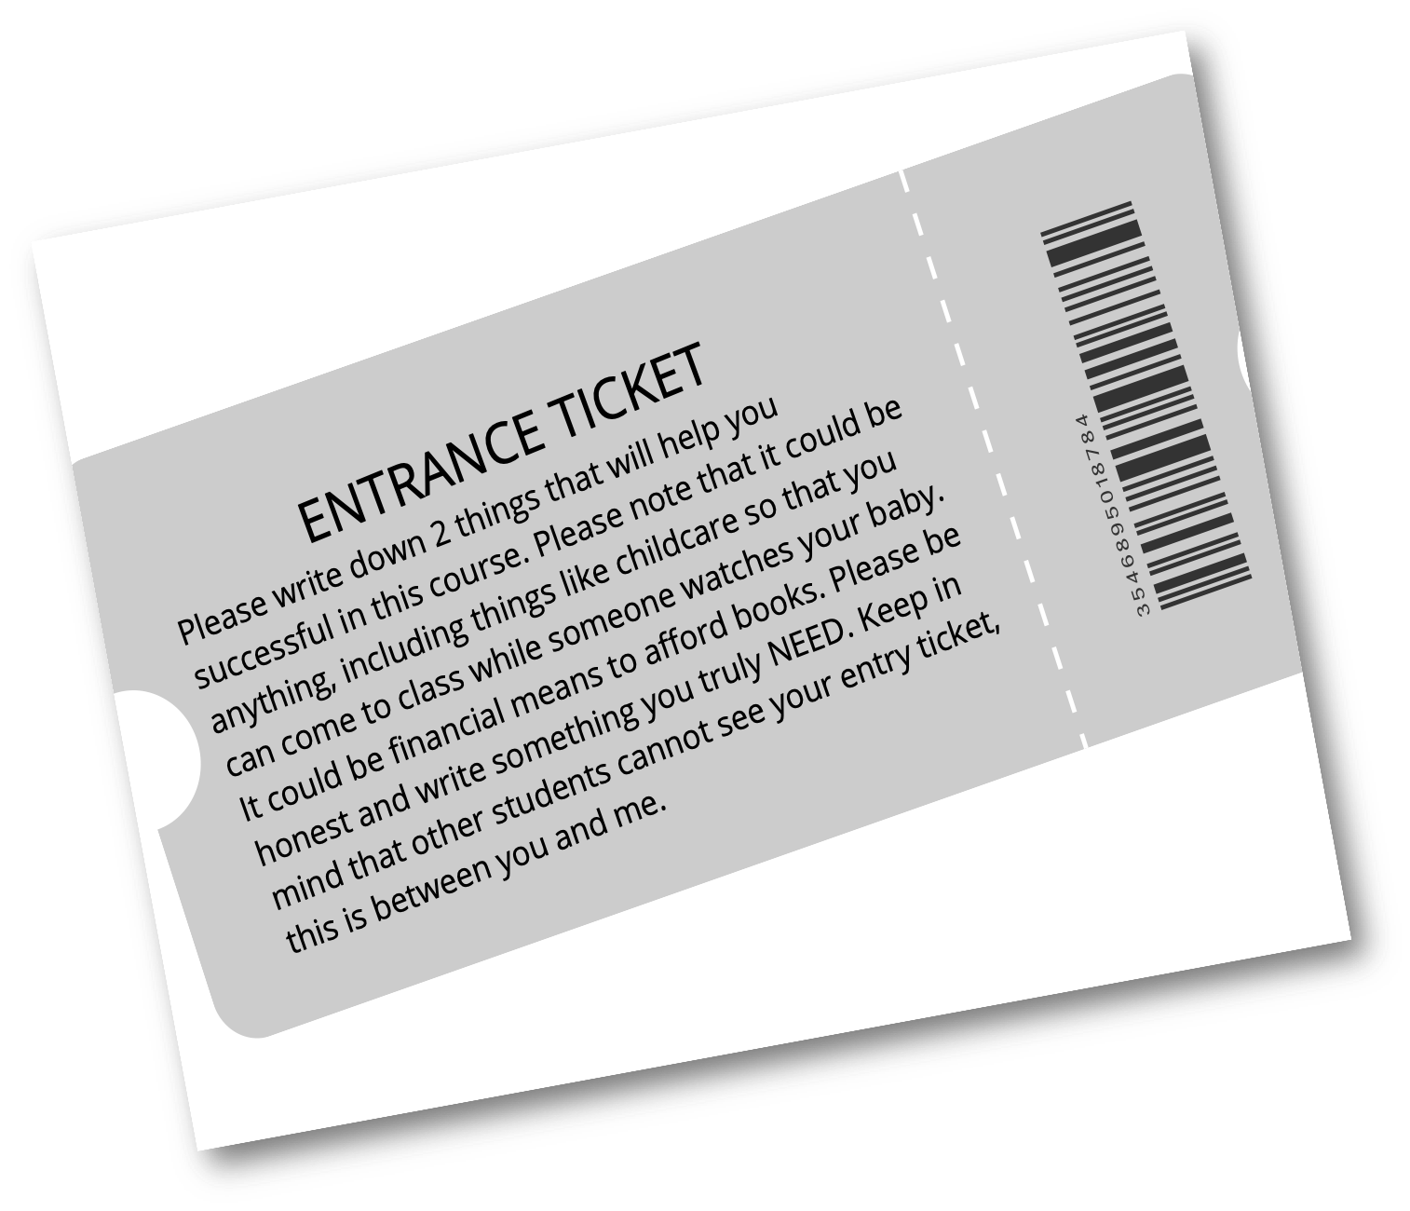

This is your entrance ticket to my course. Please feel free to use it. Inbox me the 2 things that you can think of and I will see to it that you will be successful in the class.

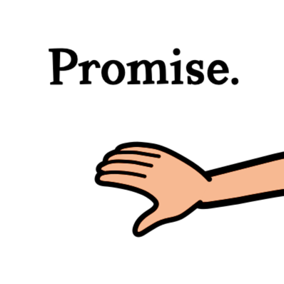

ACCT1A 06Z CRN00018 Accounting 1A, Fall 2021

Course Schedule
Week | Date | Chapter | Topics, Readings, Assignments, Exams, Due Dates
1 | Sept 21 | Orientation and 1 | 1-1 Nature of a business and role of accounting and ethics  1-2 How accounting principles are developed  1-3 The Accounting Equation
1 | Sept 23 | 1 | 1-4 Recording business transactions in relation to the accounting equation  1-5 Financial statements of a sole proprietorship  1-5 Inter-relationships of the financial statements  1-5 Introduction to the classification of accounts: assets, liabilities, equity (income, expenses and capital)  Orientation activities and chapter 1 homework due Sept 26
2 | Sept 28 | 2 | 2-1 Using accounts and chart of accounts  2-2 Classification of accounts: assets, liabilities, equity  2-2 The double-entry accounting system and posting entries to T accounts  2-2 Journalizing business transactions
2 | Sept 30 | 2 | 2-3 Posting of journal entries; The journal versus the ledger  2-4 Trial Balance and errors  2-5 Horizontal Analysis  Oct 3 is the last day to drop class without record and full refund  Chapter 2 homework, learning check on debits and credits due Oct 3
3 | Oct 5 | 3 | 3-1 What is the adjusting process? Explanation of the accrual basis of accounting.  3-2 How to prepare accruals for accounting period end?  3-3 How to prepare deferrals for accounting period end?
3 | Oct 7 | 3 | Review of accruals and deferrals and more examples  3-4 What is depreciation expense?  3-5 Description of the adjusting process  3-6 Preparation of the adjusted trial balance  3-7 Vertical Analysis and how is it useful?  Chapter 3 homework, learning check on accruals and deferrals due Oct 10  Interim Grade I
4 | Oct 12 | 4 | 4-2 Preparing the financial statements for sole proprietorship and a corporation – Income Statement, Statement of Owner’s Equity/Statement of Stockholders’ Equity and Balance Sheet  4-3 The need for closing entries and the difference between permanent and temporary accounts  4-4 to 4-5 The accounting cycle
4 | Oct 14 | 4 | 4-2 More practice on preparation of the financial statements  4-6 Fiscal year-end and publicly-traded companies  4-7 Liquidity ratios: Working capital and current ratio
5 | Oct 19 | 5 | 5-2 Manual accounting systems, subsidiary ledgers and special journals  5-3 Computerized accounting systems  5-4 E-Commerce  5-5 Segment analysis
5 | Oct 21 | Chapters 1- 4  Review for exam 1 | Midterm exam chapters 1 to 4 (180-minute exam, open from Oct 22, 12 am to Oct 24, 11:59pm)  Chapter 4/5 homework, learning check on closing entries and financial statements due Oct 24
6 | Oct 26 | 6 | 6-1 What is a merchandising business?  6-2 Recording freight and purchases and sales transactions in a merchandising business  6-2 Recording sales tax
6 | Oct 28 | 6 | 6-3 The adjusting process of a merchandising business  Practice problems  Interim Grade II
7 | Nov 2 | 6 | 6-4 Financial statements of a merchandising business (Gross profit!)  6-5 Asset turnover
7 | Nov 4 | 7 | 7-2 Inventory costing methods: FIFO, LIFO and weighted average  7-3 Perpetual inventory record  7-4 Periodic inventory record  Chapter 6 homework and learning check on multiple-step income statement and classified balance sheet due Nov 7
8 | Nov 9 | 7 | 7-5 Comparing the costing methods: how does it affect financials?  7-6 Reporting merchandise inventory on the balance sheet  7-7 Inventory turnover and days’ sales in inventory financial ratios
8 | Nov 11 |  | Veterans Day – No Class  Last day to drop a class with a W grade, Nov 12  Chapter 7 homework and learning check on inventory due Nov 14
9 | Nov 16 | 8 | 8-1 to 8-4 Discussion of internal controls of cash
9 | Nov 18 | 8 | 8-5 Bank reconciliation theory and practice  Chapter 8 homework due Nov 21  Interim Grade III
10 | Nov 23 | 9 | 9-1 Classification of receivables  9-2 and 9-4 Allowance method for uncollectible receivables  9-8 Receivables turnover and days’ sales in receivables
10 | Nov 25 |  | Thanksgiving Day – No Class
11 | Nov 30 | 9 | 9-6 Accounting for notes receivable  9-7 Reporting receivables on the balance sheet
11 | Dec 2 | Review for final exam | Final exam will have an emphasis on chapters 6 to 9  Chapter 9 homework and learning check on cash and receivables due Dec 5
Final Exam | Dec 6 - 10 |  | Final Exam chapters 6 to 9 (180-minute exam) open from Dec 5 12am to Dec 7 11:59pm  Extra Credit Data Analytics Project using Google Sheets due Dec 7, 11:59pm

Participation Rubric

Performance Elements & Levels | Approaching  (1 = 20 points) | Developing  (2 = 40 points) | Accomplished  (3 = 60 points) | Exemplary  (4 = 80 points)
Engagement & Active Participation | Student rarely participates in class discussion; fails to respond to direct questions | Few contributions to class discussions; seldom volunteers but responds to direct questions | Proactively contributes to class discussion; asks questions and responds to direct questions | Proactively and regularly contributes to class discussion; initiates discussion on issues related to class topic
Listening skills | Does not listen when others talk; interrupts or makes inappropriate comments | Does not listen carefully; comments are often nonresponsive to discussion | Listens and appropriately responds to the contributions of others | Listens without interrupting and incorporates and expands on the comments of other students
Relevance of contribution to topic under discussion | Contributions are off-topic or distract from discussion | Contributions are sometimes off-topic or distract from discussion | Contributions are always relevant | Contributions are relevant and promote deeper analysis of the topic
Preparation | Student is not adequately prepared; does not seem to have read the assigned material before class | Student has read the material but not closely, or has read only some of the material before class | Student has read and thought about the material before class | Student is consistently well prepared; sometimes adds relevant information beyond the assigned reading

