Macbeth Performance Analysis 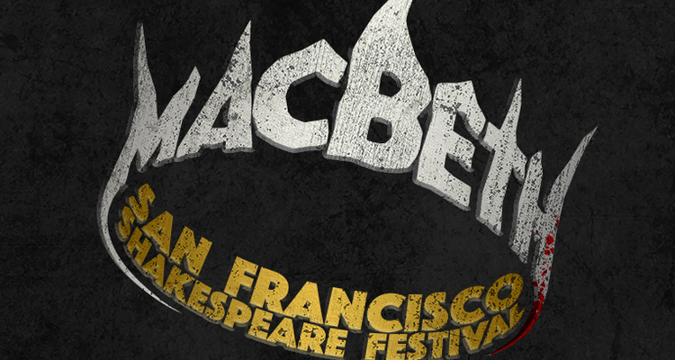

Write a 500-750 word analysis of the theatrical and thematic interpretations of the production.
http://www.sfshakes.org/programs/shakespeare-on-tour/2019-2020-macbeth/cast-of-macbeth

Consider:

1. Setting (Sound, Lighting, Special Effects)
What is the type of setting? Naturalistic, Stylized? Colorful? Atmospheric? Simple? How does the set reflect the plays themes?

2. Costume
Is the dress classic Elizabethan or another time period? How do the costumes reflect the characters or the themes?

3. Characters and Casting
Explore and analyze the choice of actors for each character. Are there any roles played dramatically differently than your interpretation from the play? It appears this version has only five actors playing multiple parts. Explore the effect of the doubling.

4. Scene Deletions
This performance is only an hour long. Explore and analyze the effect of deleted scenes or characters.

5. Dialogue
Are there any surprising changes in the dialogue? Any accents or dialects? Does this add to a thematic interpretation?

6. Pacing and Timing
Do the sequences move fast or slow? What is the effect?

